Multiple-choice section

|  |  |  |  |  |  |  |  |  |
| --- | --- | --- | --- | --- | --- | --- | --- | --- |
| Question | 1 | 2 | 3 | 4 | 5 | 6 | 7 | 8 |
| Answer | B | D | D | C | B | A | C | B |

Question 1 [2.3]

B

Let *a* be the third side of the triangle.

*a*2 + *b*2 = *c*2

*a*2 = *c*2 – *b*2

*a*2 = 172 – 162

*a*2 = 33

*a* = cm

Question 2 [2.1]

D

*m*2 + *p*2 = *n*2

*p*2 = *n*2 – *m* 2

*n*2 – *m* 2 = *p*2

Question 3 [2.5]

D

*a*2 + *b*2 = *c*2

122 + 162 = 400

= *c*

*c* = 20

(or simply recognise as (3, 4, 5) tripled)

Question 4 [2.2]

C

*c*2 = *a*2 + *b*2

*c*2 = 18.222 + 8.922

*c*2 = 411.5348

*c* = 

*c* = 20.29 (2 d.p.)

Question 5 [2.2]

B

is irrational, so B is incorrect. The other three statements are true.

Question 6 [2.4]

A

The ladder, the wall and the ground form a right-angled triangle.

In the original position, the side lengths are the Pythagorean triple (1.5, 2, 2.5). The original height is 2 m.

When the ladder is moved the length of the hypotenuse is 2.5 m and one short side is 1 m. A calculation is needed to find the length of the other short side.

Question 7 [2.2]

C

Let the value of the diagonal be *z*.

*z*2 = 17.482 + 9.522

*z* 2 = 396.1808

*z* = 

*z* = 19.90

Question 8 [2.5]

B

72 + 242 = 625

252 = 625

(7, 24, 25) is the Pythagorean triple.

Multiple-choice total marks: 8

Short answer section

Question 9 3 marks [2.1, 2.2, 2.5]

**(a)** In a right-angled triangle, the hypotenuse is the side opposite the right angle.

**(b)** To find the length of the hypotenuse, we take the square root of the sum of the squares of the two shorter sides.

**(c)** By showing that the numbers in Pythagorean triples satisfy Pythagoras’ theorem, we show that these numbers could represent the lengths of sides of a right-angled triangle.

Question 10 3 marks [2.4]

**(a)** Bill’s incorrect step: 172 + 202 = *k*2

Jan’s incorrect step: 32 = *k*2

**(b)** Bill thinks that *k* was the hypotenuse. His first step should be *k*2 = 202 – 172 or  *k*2 + 172 = 202.

Jan incorrectly subtracts 17 from 20 before squaring the values.

Question 11 2 marks [2.1]

Δ*DEF*:

1252 + 131.252 = 32851.5625

181.252 = 32851.5625

9.72 + 9.062 = 13.2732

Pythagoras’ theorem holds.

Δ*DEF* contains a right angle at *D*.

Δ*ABC*:

10.222 + 7.662 = 163.124

12.162 = 147.8656

10.222 + 7.662 ≠ 12.162

Pythagoras’ theorem does not hold.

Δ*ABC* does not contain a right angle.

Question 12 2 marks [2.1]

**(a)** *t*2 + 8.62 = 18.32

**(b)** *y*2 + *z*2 = *x*2 or *x*2 = *y*2 + *z*2

Question 13 1 mark [2.1]

Lengths should be very close to accurate in student workings.

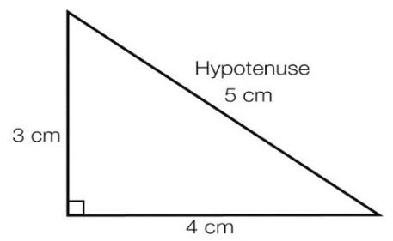

Question 14 2 marks [2.2]

*w*2 = 8.882 + 17.922

*w*2 = 399.9808

*w* =

*w* = 19.9951

*w* = 20.00 (2 d.p.)

Question 15 2 marks [2.2]

*m*2 = 72 + 32

*m* 2 = 49 + 9

*m* 2 = 58

*m* =

Question 16 2 marks [2.3]

Let *x* be the unknown side.

*x* 2 = 16.082 – 6.212

*x* 2 = 220.0023

*x* =

*x* = 14.83 (2 d.p.)

Question 17 2 marks [2.3]

*t*2 + *t*2 = 

2*t*2 = 

2*t*2 = 20

*t*2 = 10

*t* =

Question 18 2 marks [2.3]

*v*2 = 19.112 – 5.222

*v*2 = 337.9437

*v* =

*v* = 18.38 (2 d.p.)

Question 19 3 marks [2.4]

Let *w* metres be the height of the top of the ladder.

*w*2 = 2.12 – 0.92

*w* 2 = 3.6

*w* =

*w* = 1.90 (2 d.p.)

Difference between ladder and picture heights = 1.92 m – 1.90 m = 0.02 m or 2 cm

The top of the ladder is 2 cm below the picture.

Question 20 3 marks [2.4]

Let 2*x* be the distance between the two pegs.

*x*2 = 172 – 152

*x*2 = 64

*x* = 8 m

Therefore, 2*x* = 16 m

The distance between the pegs is 16 m.

Question 21 2 marks [2.5]

If triples are not known, use Pythagoras’ theorem.

**(a)** *h*2 = 52 + 122

*h*2 = 169

*h* =

*h* = 13

**(b)** *b*2 = 412 – 92

*b* 2 = 1600

*b* =

*b* = 40

Question 22 *2 marks* [2.5]

**(a)** 102 + 602 = 3700

612 = 3721

102 + 602 ≠ 612

Pythagoras’ theorem does not hold.

Therefore, (10, 60, 61) is not a triple.

**(b)** 122 + 352 = 1369

372 = 1369

122 + 352 = 372

Pythagoras’ theorem holds.

Therefore, (12, 35, 37) is a triple.

Short answer total marks: 31

Extended answer section

Question 23 5 marks [2.1]

**(a)**

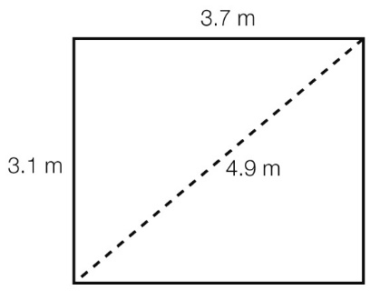

**(b)** 3.12 + 3.72 = 23.3

4.92 = 24.01

3.12 + 3.72 ≠ 4.92

Therefore, the room is not ‘square’.

**(c)** Adjustments needed to ensure the room is square:

length: 3.1 m → 3 m

width: 3.7 m → 4 m

diagonal: 4.9 m → 5 m

32 + 42 = 25

52 = 25

32 + 42 = 52

Thus, the room will be ‘square’ with these dimensions.

Question 24 9 marks [2.2, 2.4]

(a)

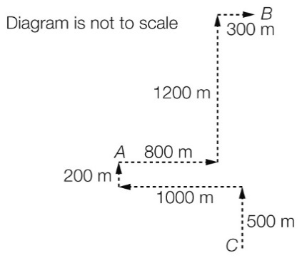

**(b)** John:

800 + 1200 + 300 = 2300 m

Annabelle:

200 + 1000 + 500 = 1700 m

2300 – 1700 = 600 m

John walks 600 m further than Annabelle.

**(c)** Let *x* be the length of the line.

*x*2 = 11002 + 12002

*x*2 = 2 650 000

*x* =

*x* = 1627.88 m

**(d)** Let *d* be the length of the line.

*d*2 = 7002 + 10002

*d*2 = 1 490 000

*d* =

*d* = 1220.66 m

**(e)** 1627.88 – 1220.66 = 407.22 m

Thus, Annabelle lives closer by 407.22 m.

Question 25 5 marks [2.5]

**(a) (i)** (12, 16, 20)

**(ii)** (40, 42, 58)

**(b)** (9, 40, 41)

(11, 60, 61)

|  |  |  |  |
| --- | --- | --- | --- |
| ***b*** | **(*b*2 – 1)** | **(*b*2 + 1)** | **Triple** |
| 9 | 40 | 41 | 9, 40, 41 |
| 11 | 60 | 61 | 11, 60, 61 |

**(c)** (3, 4, 5)

(8, 15, 17)

|  |  |  |  |  |  |
| --- | --- | --- | --- | --- | --- |
| ***g*** | ***h*** | ***g* + *h*** | ***gh*** |  | **Triple** |
| 1 | 3 | 4 | 3 | 5 | 3, 4, 5 |
| 3 | 5 | 8 | 15 | 17 | 8, 15, 17 |

Extended answer total marks: 19

TOTAL test marks: 58